Shreya Panchal
Cyber Security Internship Program.
Week 3 – Local Networking & Tools
Task 9: Wireshark – Capture & Analyze Packets
1.Capture network traffic
2.Apply filters (HTTP, DNS, etc.)
3.Observe packet flow and structure
1. Capture Network Traffic
- Open Wireshark and select the active network interface (e.g., Wi-Fi or Ethernet).
- Click Start Capturing.
- Wireshark begins recording all packets passing through your system—like HTTP requests, DNS lookups, ARP, TCP handshakes, etc.
2. Apply Filters (HTTP, DNS, etc.)
Filters help you focus on specific traffic:
 | Purpose | Filter
 | Show only HTTP packets | http
 | Show only DNS queries/responses | dns
 | Show only TCP packets | tcp
 | Show only UDP packets | udp
 | Filter by IP | ip.addr == 192.168.1.5
 | Filter by port | tcp.port == 80 or udp.port == 53
3. Observe Packet Flow & Structure
Click on any packet to view its breakdown:
- Frame – Metadata about the captured packet.
- Ethernet Layer – Source & destination MAC addresses.
- IP Layer – Source & destination IP addresses, TTL, protocol type.
- TCP/UDP Layer – Ports, flags, sequence numbers.
- Application Layer – Protocol-specific data (HTTP requests, DNS queries, etc.).
Example flows:
- HTTP flow → request → response
- DNS flow → query → answer
- TCP flow → 3-way handshake (SYN → SYN/ACK → ACK)
Task 10: Nmap Scans
Run and record the outputs of:
1. nmap -sn 192.168.1.0/24 (Ping Scan)
2. nmap -O <target_ip> (OS Detection)-0w 3ws7
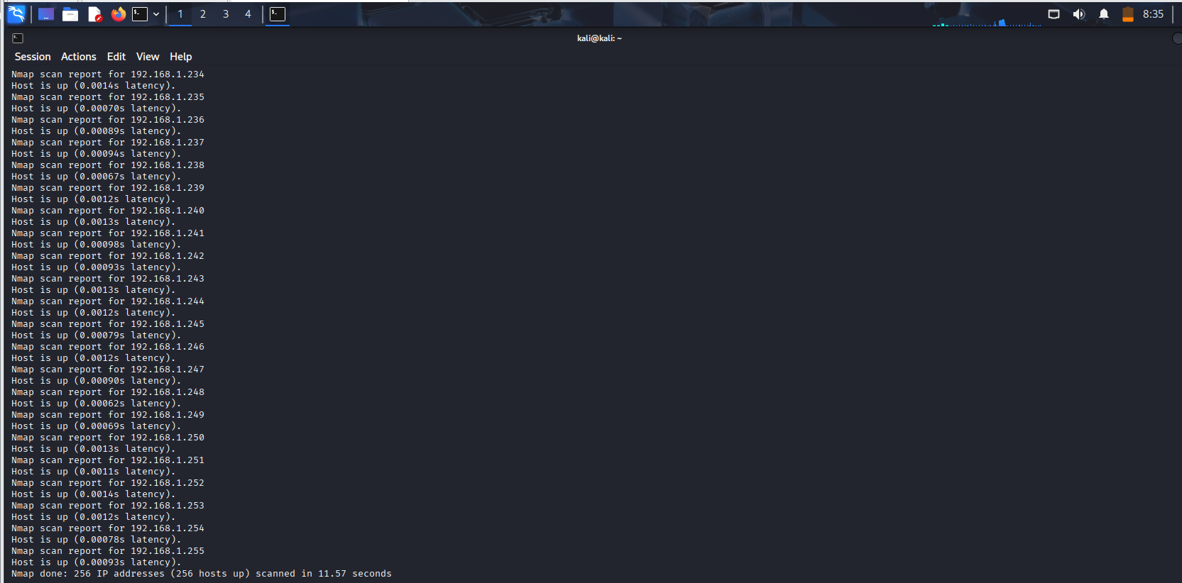
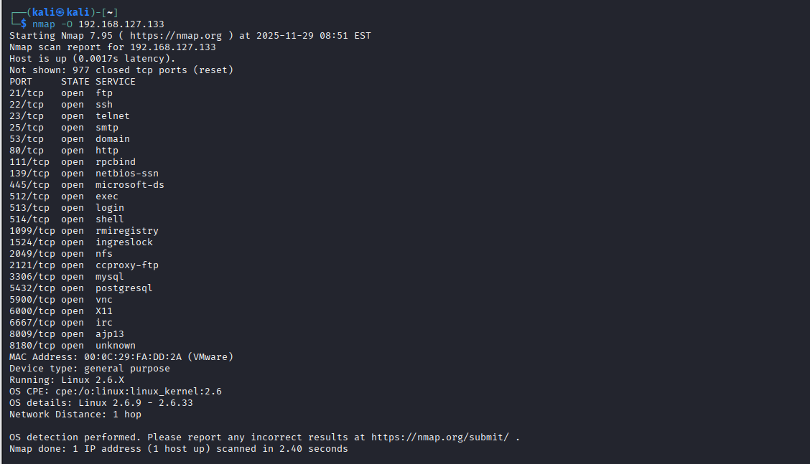
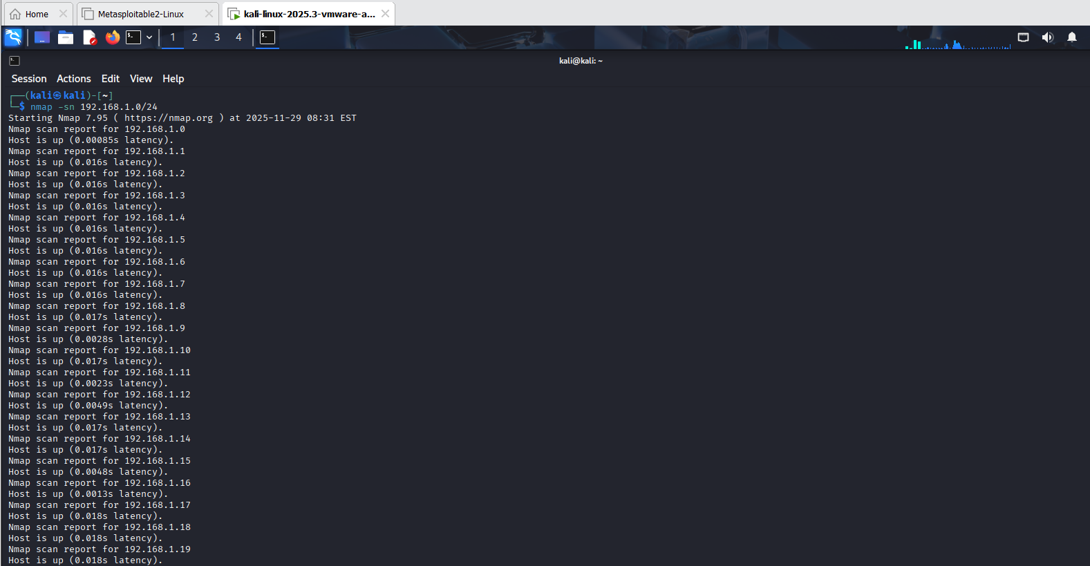
Task 11: Setup File Transfer (FTP/SFTP)
1. Install vsftpd or proftpd
2. Set up access
3. Test upload/download using FTP/SFTP client
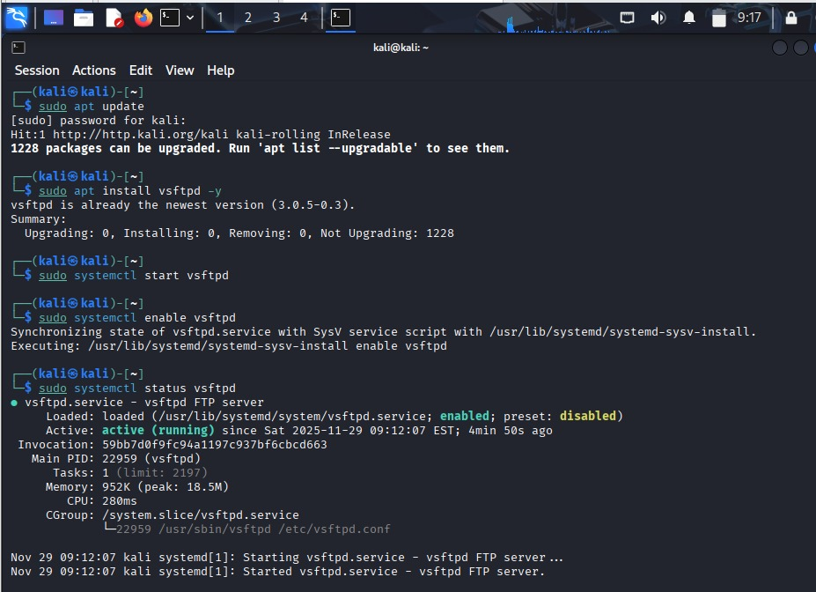
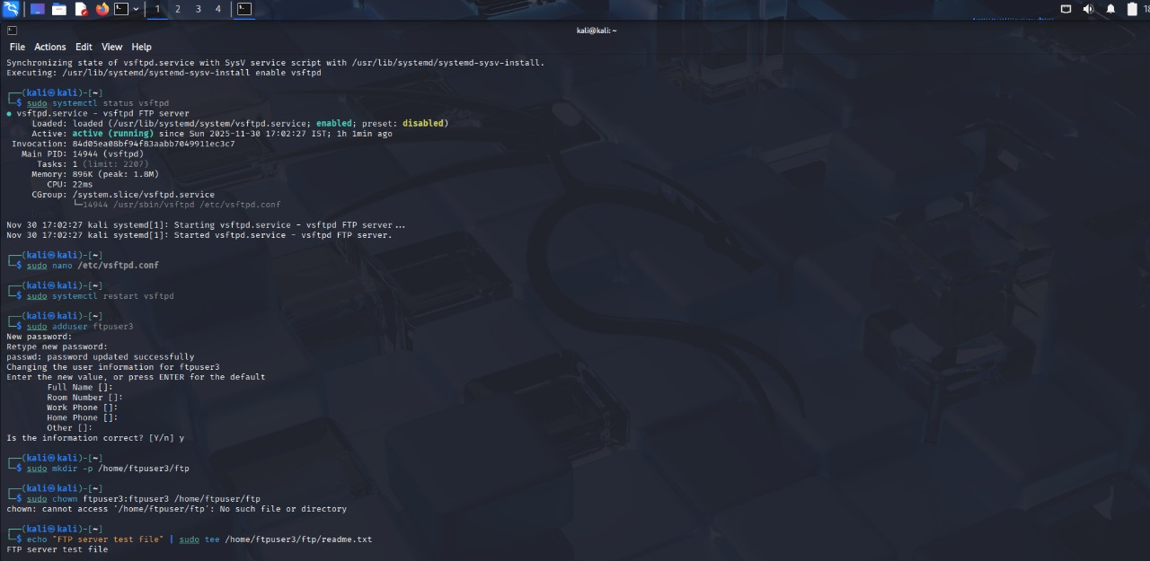
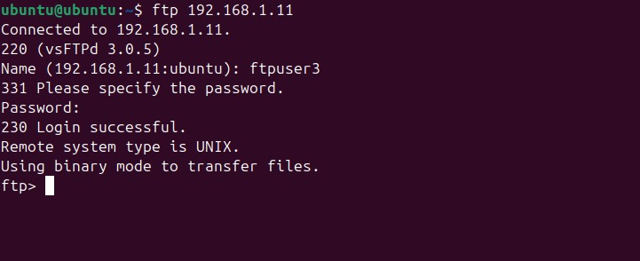
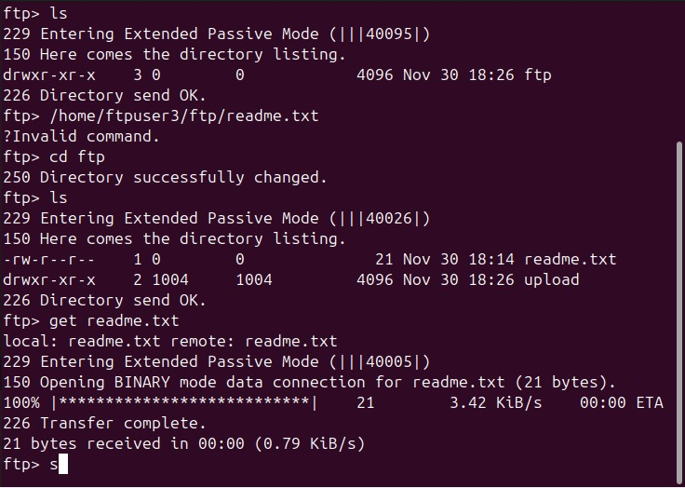
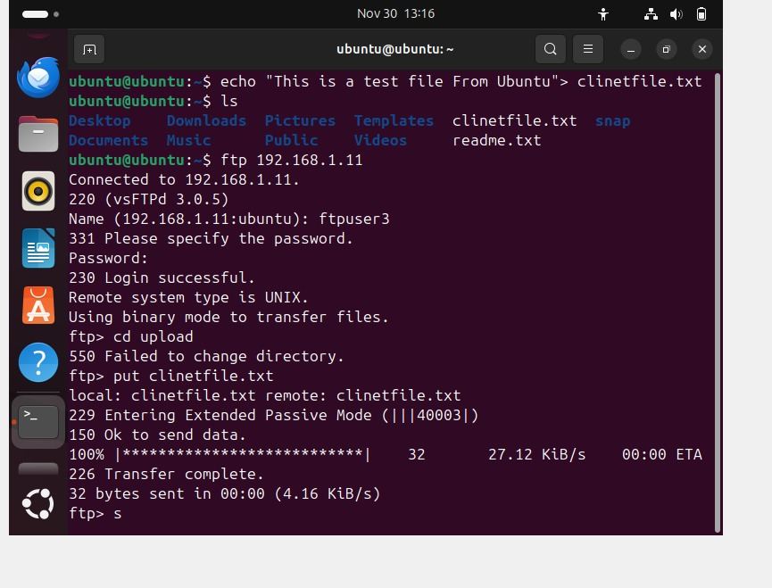
Task 12: Document Network Topology
Draw a clear diagram of your VMs, IPs, services, and connections.
